How Round are Your Wheels?
One of the most asked questions I get from scouts and parents about the Pinewood Derby kits is should they do anything with the wheels for roundness. They are asking if they should sand or machine the wheels to make sure the wheels are completely round. The more a wheel is out of round, the more the wheel will bounce as it rolls. It is true that a completely round wheel will be a faster wheel but how good are the wheels that come out of the box? Do they need machining?

History
Since Pinewood Derby started in 1953, the supplier has been improving the wheels that come with the kits. Previous to the year 2000, it is true that many of the wheels supplied were not very round with multiple voids or mold marks that affected their roundness. This required a process to make the wheels round and usable. Scouts would use sandpaper or a wheel shaver tool to bring the wheels back to roundness. This would improve the speed of their cars. In many older tip booklets, you will see scouts rounding the wheels to remove these mold marks.
In 2000, the wheel molds were remade and wheels improved significantly. The wheels were made lighter using less plastic improving the overall speed of a car. Also, the injection points were moved from the wheel tread to the inside of the wheel. By doing this, this did not leave a mold mark or ‘bump’ on the portion of the wheel making contact with the track. Overall, by using better technology, the molds were of much better quality producing a better wheel.

Testing Process
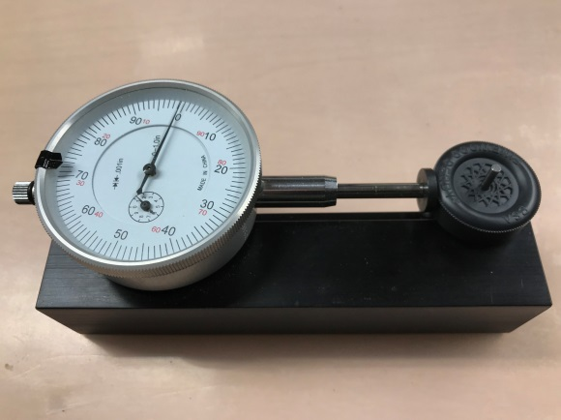
To test the roundness of wheel, a tool is used called a concentricity gauge (right). This tool measures the distance between the axle hole and the wheel surface. The wheel is mounted on pin gauge, acting as an axle, that is as close to the wheel bore as possible. By rotating the wheel, you can see the uniformity or the roundness of the wheel. Any difference in distance is called runout. The runout is usually measured in thousands of an inch (0.001”) using an accurate machine dial gauge. The lower the runout, the more round a wheel is.

Results
So, how round are the wheels that come right from the box? The short answer is really pretty good. The runout measured for black wheels was between 0.0025” and 0.0040” for the wheels I tested. To give you some perspective, the thickness of a sheet of copy paper is around 0.0030″. I also tested colored wheels for their roundness. My findings were somewhat alarming. The colored wheels consistently had flaws that had a runout of over 0.010”. I think that is due to the fact that they make fewer colored wheels and possibly use less accurate molds.

What to Do?
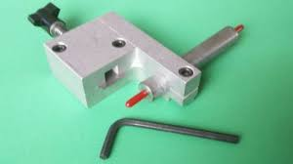
Can you do anything to improve the roundness of your wheels? Short answer: yes. But, the reality is unless you are a machinist with high priced equipment and training, there is an excellent chance you will make the wheel worse by trying to make it better. There are some tools available on the internet for shaving or rounding the wheels. One tool is called a Wheel Shaver (left) is available for about $50. This tool uses a razor-like blade to shave the wheels around a concentric axle. This tool is not designed to be used by a young scout. My experience with this tool has been even if used carefully by an adult, the results don’t warrant it’s purchase. In one test, I had a scout use the tool after training. The wheel had a runout of 0.0050” before tooling and a runout of 0.0080” after shaving. The wheel was worse after the scout carefully shaved the wheel. If you use colored wheels, there was an improvement in reducing the flaws and making a better wheel by machining.

Conclusion
My conclusion is the black wheels supplied with your kit, with rare exceptions, are pretty good out of the box. If you do find one that has flaws, I would buy another kit or wheels to find a better one. Chances are having four wheels to start with should produce 4 wheels that are very good. If you elect to machine or work the wheels, there is a good chance that you will not improve their quality but reduce it. If you are using colored wheels, my experience has been that they will need some work.
I have a video that you can view to see how the testing is done and the actual results using some wheels out of the box. You can view it here: https://youtu.be/lF3Ae4oeH-A

